**Display of Chemical Components and**

**Nutrients of Leaf Using ML**

Vigneshkumar R, Rupasri D, Sudheshna P

I ECE - C

MENTOR: Dr. Ramalingam, Dept of ECE

**1.Introduction:**

During the pandemic, COVID-19 had a widespread impact on many individuals. Scientists, pharmacists, and other professionals worked tirelessly to find a solution for the virus. However, developing an effective vaccine took considerable time. If a leaf chemical content analysis product had been available, researchers could have used it to explore whether a potential remedy for COVID-19 existed in nature. This innovative tool could have provided valuable insights and accelerated the search for a solution to the global health crisis.

**2.Objective:**

The lack of awareness and understanding about the specific properties, nutrients and chemical composition of different types of leaves hinders their effective utilization and limits potential benefits in pharmacology, agriculture and environmental studies.

**3.Market Analysis:**

As per NCBI, there has been significant growth in the herbal drugs market around the world, over the last few decades due to growing awareness among people about the rising cost as well as side effects related to the use of synthetic drugs.

Herbal Medicine Market size to grow by USD 39.52 Bn | 42% growth to originate in Asia | Technavio

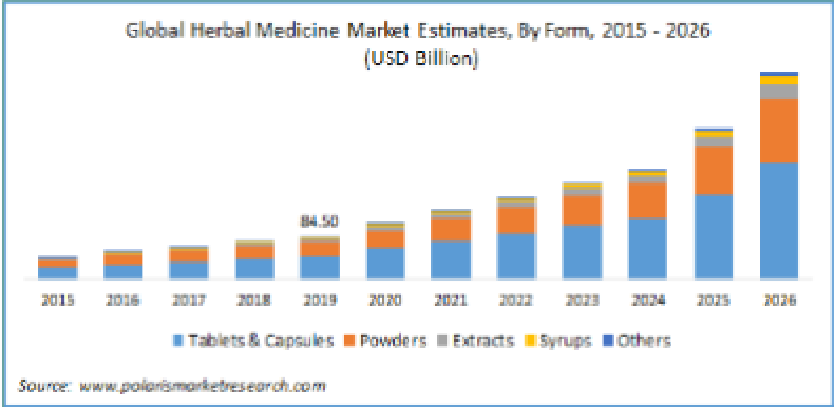

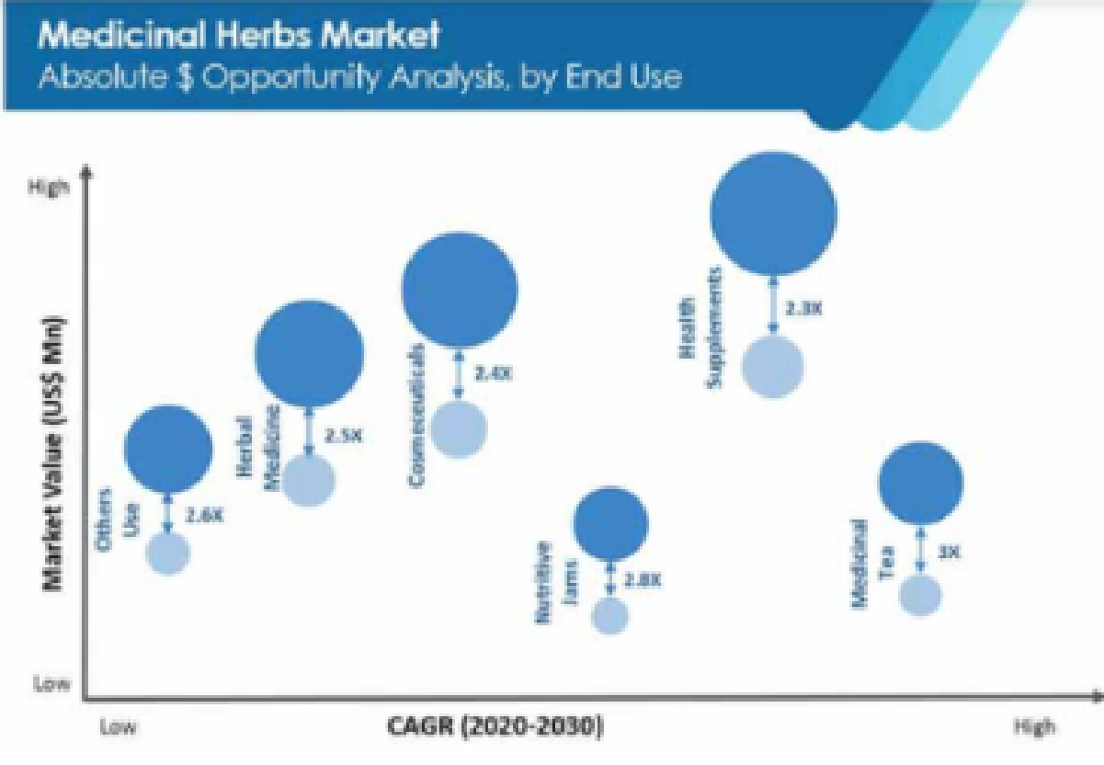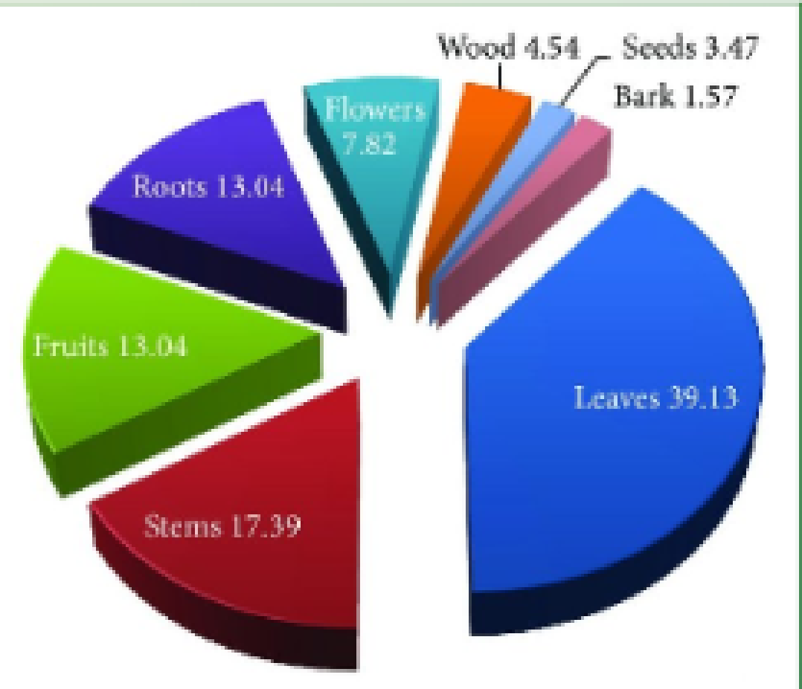

**4.Solution:**

By using machine learning we will easily scan the image of the leaf and train the system to find the chemical content present in it and which can be later useful for pharmacists to prepare medicine.To get the chemical composition and nutrients of the particular leaf.

**5.Target customers**

* Educational Institutions
* Students and Researchers
* Agricultural Professionals and Farmers
* Environmental Organizations
* Gardening and Landscaping Enthusiasts
* Nutrition and Health Advocates
* Food Industry and Herbal Medicine Practitioners

**6.Block diagram:**

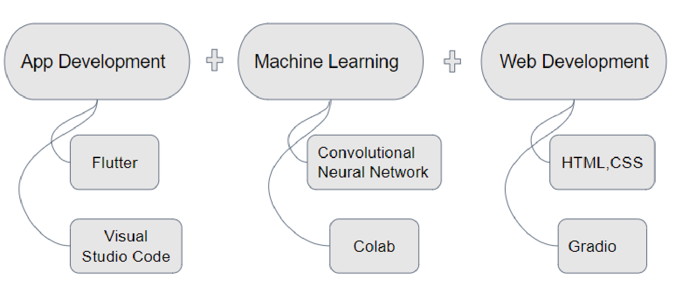

**7.Flow Diagram:**

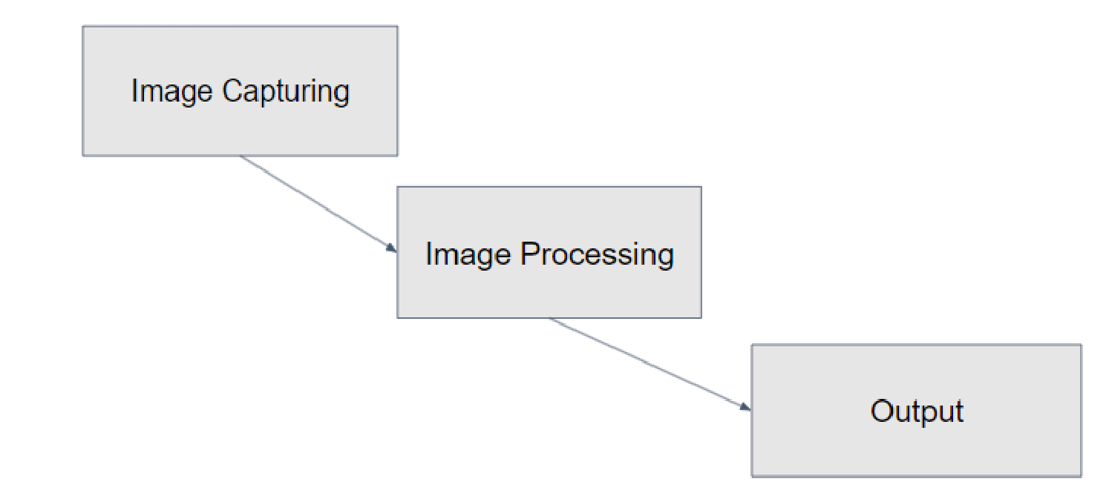

**8.Output:**

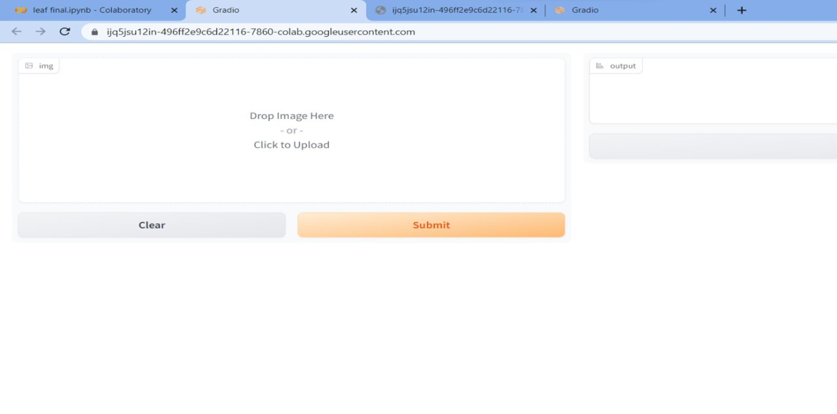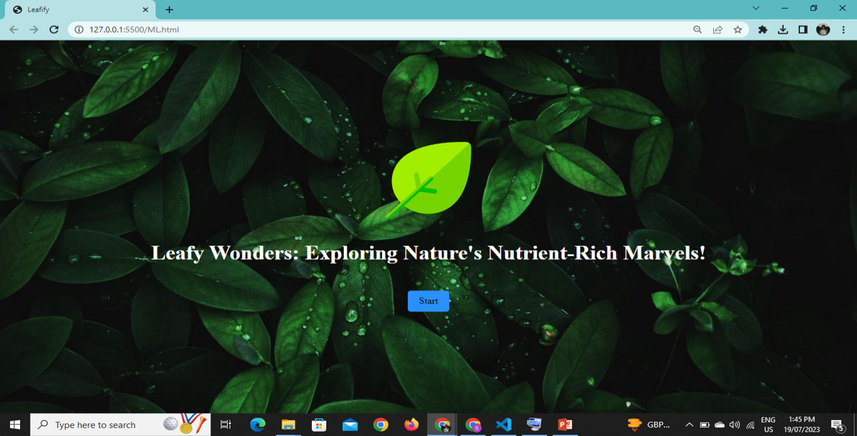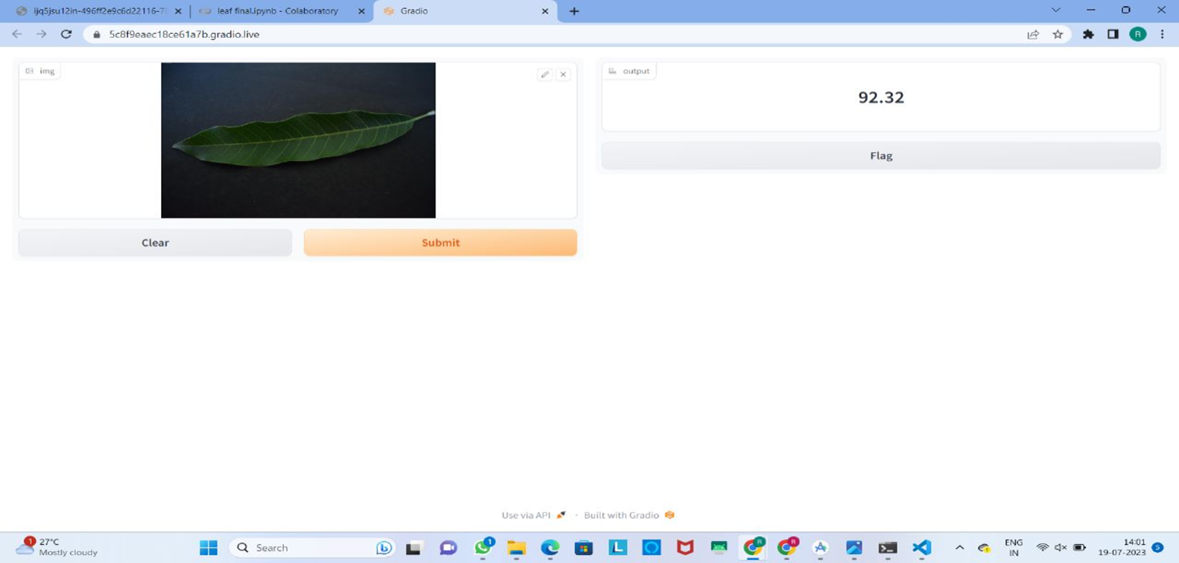

**9.Conclusion:**

* This project has delved into the fascinating world of leaves, exploring their chemical components and nutrient content. Through meticulous research and analysis, we have uncovered the vital role that leaves play in sustaining life on our planet.
* By sharing this information, we aspire to foster a greater appreciation for nature's intricacies, encouraging sustainable practices that preserve and protect the precious gift of life provided by leaves and the rich biodiversity they sustain.

**10.References:**

* <https://flutter.dev/>
* <https://stackoverflow.com/>
* <https://www.wikipedia.org/>
* <https://www.kaggle.com/>
* <https://ieeexplore.ieee.org/>